- 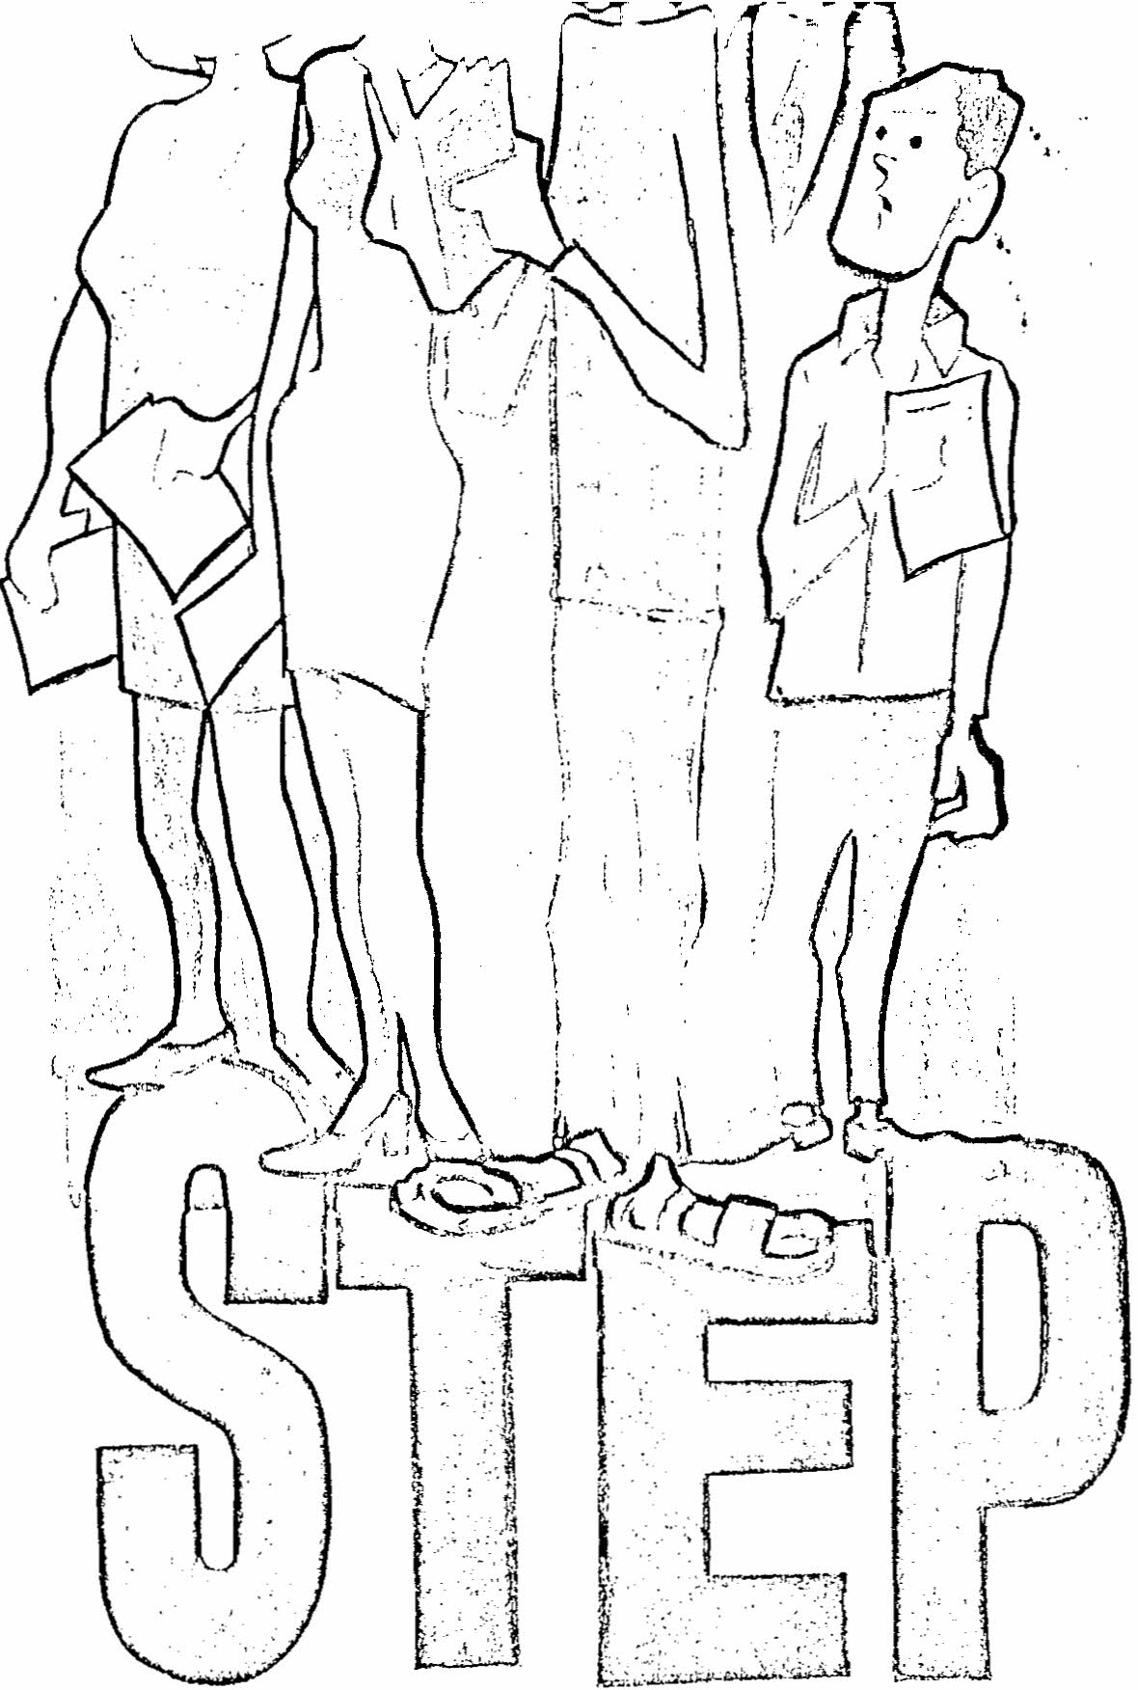
-"~>~--·T·"'·""'-

...

This presentation is designed to give new students a general
orientation to the S. T. E. P. Program as used at Holland College.
S. T. E. P. means Self-Training and Evaluation Process.

Note: Scanned from the paper copy, with cover as above, and retyped by Don Glendenning on June 13, 2010

1 Many of you know how to drive a car and can do so with little effort but how long did it take you to acquire this skill? Did you require less time to learn to operate a car than your brother or sister needed? Did you take less time because you had driven a tractor, or a bicycle, or a Go-Kart, when you were younger?

2 To apply this example to learning generally we find that each person can learn but some of us learn more, quickly than others. Therefore, the most efficient way to learn a group of facts or skills is to do so on an individual basis.

3 If you were learning to drive a car would you prefer to use an actual car, or would you rather grasp a dummy steering wheel in your hands and try to imagine you are in a car?

Consequently, when you are learning the environment in which you learn should duplicate as closely as possible the actual environment in which you will apply your learning.

4 If you were going to be driving in Canada you would need to learn how to drive on the right hand side of the road rather than on the left hand side. If you plan to be a truck-driver you would have to learn well enough to pass the test for your Chauffeur's licence.

Obviously the standards of competence set for the area in which you are going to use the skill are the ones you should strive towards while in training.

5 Holland College believes that learning should be individualized and relevant to the occupational field with regard to environment and standards of achievement.

6 To be more specific, if you were training to be a plumber you should be able to learn at the speed which best suits you as an individual. You should also be trained so that you can work with all types of plumbing systems, tools and equipment, and you should be trained to be as competent as other plumbers now working.

7 In order to put these beliefs into practice Holland College has adopted a new approach to Curriculum. We as an Institution are now using the S. T. E. P. system.

By means of this presentation, we hope to give you some understanding of the
development, philosophy and effect of S. T. E. P. Following this presentation you will receive more specific orientation from the Instructors in your individual Departments.

8 The basis of the S. T. E. P. Program is the Course Chart. Let's take the example of the plumber again. In order to develop a Course Chart for plumbers we would call in a group of people who were working in the plumbing field and who have had a wide variety of experiences within this area. We may have six plumbers on the Committee and one or two of these may own their own plumbing businesses, another two or three may work for an employer, and several more may be Inspectors.
This Committee would sit down and with the help of a S. T. E. P. Consultant begin to identify the general areas in which a plumber must be competent in order to be employed. These general areas of competence are listed in large letters on the right hand side of your Chart these are the long-term goals to which you will be working.

9 Once the general areas of competence are established, the Committee sets about identifying the specific tasks that a plumber must accomplish before he can be competent in that area. These specific tasks are described in the small blocks on the Chart. Each of these completes the statement "The Individual must be able to …..".

10 The procedure followed in the application of S. T. E. P. is likely what interests you most. Upon entry into as S. T. E. P. Program you wi1l be given your own copy of the Chart for your occupational, field. You will be asked to read carefully every
part of the chart and then to identify those specific tasks which you may have done previously.

If you had helped in a plumber's shop for a summer you may have worked with plumber's tools and equipment and have done small
jobs around the shop. Now you must decide how well you performed
in these tasks, in relation to the rating scale which is on the far right of your Chart.

11 The ratings you give yourself are then discussed with the instructional staff of your Department. You may agree to upward or downward changes in these ratings during this
discussion. The entry ratings are placed in a small diamond in the lower left hand corner of the box.

12 Now you the Student must choose a new task or you may elect to try and improve one of your entry ratings. Once you have chosen the task it is your responsibility to try the task. After completing the task you rate yourself and then get a rating from a Staff member who has been supervising your progress.

If you are satisfied with your performance on that particular block you can now set the task aside and go on to another. If you are not satisfied with your performance you may try the task again or you can first consult the information package which has been prepared by the Instructor and which relates directly to the task at hand.

13 This package may contain printed matter, magazine articles, tape recordings, video-tapes, lab. experiments etc. Each box on the Chart has a corresponding package of information on the shelf in your Department.

14 The rating scale at the right of your Chart is the most important part of the S. T. E. P. Program. Briefly it ranges from “0” to “6” for example the "3” level which reads “Can perform this task satisfactorily without assistance &/or supervision” is the level at which most people now working in the occupational field operate. You should, therefore, measure your performance against that of people now employed in your occupational field.

One question you can ask yourself is “Did I do this task well enough to be paid for it ?" Your Instructors are familiar with what is demanded by business and industry, and they will be able to help you compare your performance with that of others.

15 And so this procedure is repeated time and again until you have developed a certain set of skills. This combination of skills is ca11ed a "Ski11 Profile” and you can see it on your Chart at a glance.

16 How S. T. E. P. affects you. It is easy to see that the program you are about to begin is very different from your previous educational training". The spotlight is now s h i n i n directly on you. The Instructional Staff is standing ready to give you assistance and guidance but the extent of your efforts will determine your degree of success.

17 To illustrate this point it may be helpful to tell you the story of a building contractor who was planning a three month trip to Bermuda. Before he left he called his foreman, a long time and loyal employee, and asked him to supervise the building of a house while the contractor was on vacation. They agreed to the size, location and design. The contractor emphasized that the foreman was to use the very best of materials and was not to worry about the expense. The contractor left for
Bermuda and the foreman began to work on the house. He disregarded his employer's instructions and cut many corners, less cement and more sand, 2”x4" instead of 2”x6", cheaper carpeting and fixtures. Upon the contractor’s return the foreman showed him the completed house and gave the keys to the contractor, but the contractor handed them back and said "You keep the keys, this is your house. I built it to thank you for your long and loyal service".

18 You are about to begin building your house, a structure made up of the skills and knowledge you acquire while at Holland College. It is up to you how well you build your house, how well you learn the skills that will enable you to reach the
occupational goal you have set for yourself. You will need some skills basic to your occupational field but once you have acquired these you should concentrate on the finishing touches. Those skills that will give you the more responsible and challenging position.

19 You would be well advised to build your house as well as you can using quality materials that are available to you. The investment you make now will reap large returns once you become part of your occupational field.

